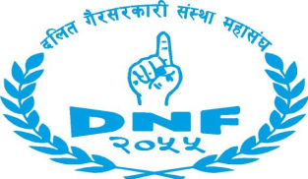
Vacancy Announcement

Dalit NGO Federation (DNF), founded in 1998, a recognized and credible umbrella organization of nearly 350 Dalit NGOs working for the empowerment and inclusion of Dalit community is implementing the project entitled "Access to Justice of Dalit through Legal Empowerment ", in partnership with Open Society Foundation (OSF) and technical support of Alliane for Social Dilouge in Siraha and Saptari. Therefore, DNF is looking for experienced and highly qualified Nepali candidates to apply for the following positions:

1. Program Officer – 1 (Kathmandu): Program Officer will be responsible for overall leadership, coordination and management of the project in the districts. The position will be based on Kathmandu and closely work with the districts and concerned stakeholders and requires regular field visits to support local community groups for effective planning and implementation of the project activities.

Required qualification: Bachelor Degree in social science or any relevant field with at least 2 years of experience in similar working areas.
Skills required: Communication, documentation, coordinator, social mobilization planning, monitoring and Reporting.

2. Program cum Finance Assistant (including Kathmandu): The main purpose of this position is to provide admin, finance; logistic and secretarial support for the district offices. She/He will responsible to manage documentation of financial expenses of the project activities and keep safety the bill and voucher, update financial the information and submit DNF central officer
Required qualification: +2 education, preferably commerce with at least 2 years of experience of program and finance management skill in NGO background.
Interested and competent applicants who meet the criteria are requested to apply outlining why you think you are qualified for the position along with your updated CV by the December 2016. Applications can be submitted by email (dalitngofederation@gmail.com).Applicants from Dalit, women and other marginalized communities will be highly encourage to apply.

Only shortlisted candidates will be contacted for the selection process

